Overview

The overall objective of this job aid is to instruct business users about the demand meter for GS and GSD customers having OTA Index KWH and KVARH reads. These are also the AMI demand meters whose peak demand is calculated over the air.

Business Process Procedure Overview
Items to be discussed in this job aid includes:
- Eligibility
- Characteristics of AMI meter having OTA Index KWH and KVARH reads
- Monitoring
- Estimation and Validation

The following rate categories are eligible:
- GSD_1120 and GSD_1130
- GS_1100 and GS_1110 customers participating on rate analysis

Characteristics of AMI meter having OTA index reads
- Advanced Meter Capability Group (AMCG) having the Remote Reading activated. These are 1002 or 1003.
- AMS is OpenWay Collection Engine (OWCE)

Monitoring
- AMI Monitor button is available in the meter reading order, meter reading results, and billing order screen

Estimation and Validation
- Existing Estimation and validations rules of SAP ECC will be followed for Index Reads KWH and KVARH

AMI Meter having remote read capability will have an AMS OpenWay Collection Engine (OWCE) and the Advanced Meter Capability Group (AMCG) either 1002 or 1003.

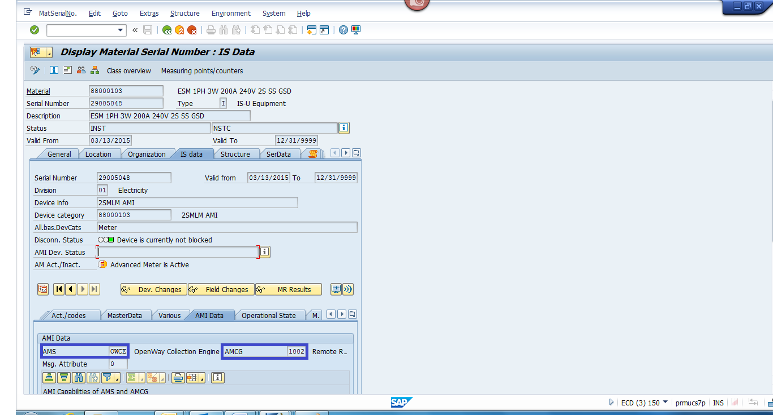

In release R4C PostCutover to Interval Billing, AMI demand meters are being deployed where the KWH and KVARH reads are being read over the air.

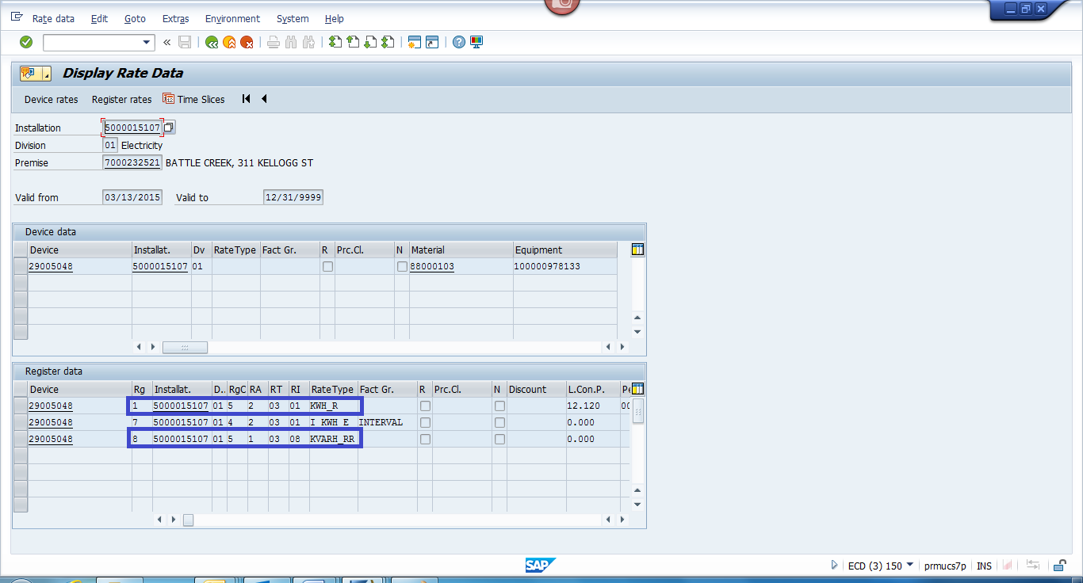

The read request are being created and sent to the MDM automatically by the nightly batch jobs or manually using transaction EL01.

Meter Reading Orders can be monitored using the AMI Monitor button. Select the items you want to monitor then click on the AMI Monitor button.

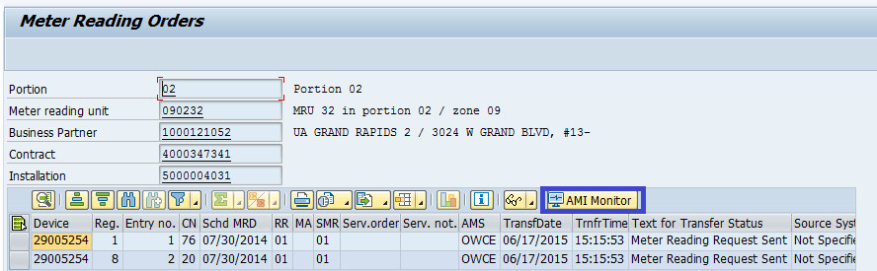

The AMI Monitor button is also available in the meter results and the billing order screen.
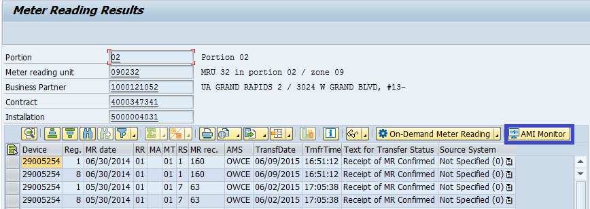

The AMI Monitoring screen is displayed below.
